Steps to handle the incident:
- View the incident in Service Now for your team:

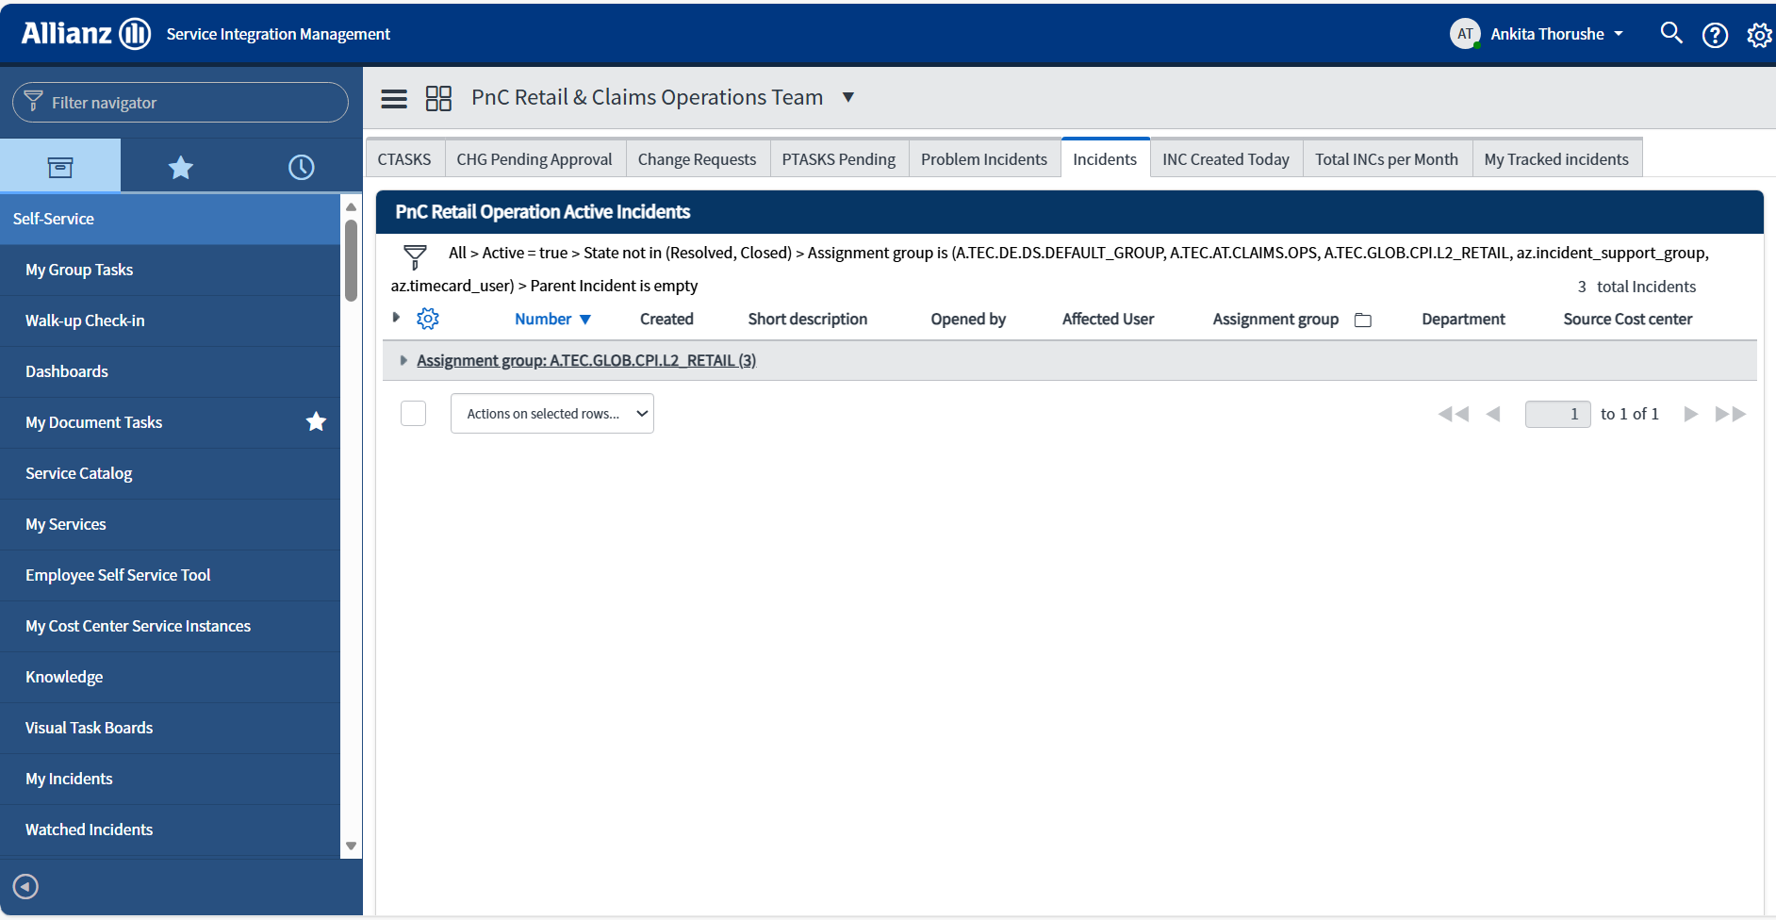

- Assign the incident to yourself. And add your name to track list
- Update Business Service(BS), Service Offering (SO), Category , Sub Category
  - Category :- ITMP BMP
  - Sub Category : - 1- Home 2- Motor 3- Home/Motor
Home :- related to home insurance
Motor:- related to vehicles
Application/ Component name | Service Offering | L3 Operations Assignment Group | L3 Application SNOW Assignment group
NTS – Notification FNOL | 911116_Claims Notification (Retail) | A.TEC.AT.CLAIMS.L3.OPS | A.AU.AU.CPI.BMP.CLAIMSHANDLING
NTS – Solution Offering | 911119_Claims Settlement (Retail) | A.TEC.AT.CLAIMS.L3.OPS | A.AU.AU.CPI.BMP.CLAIMSHANDLING
NTS – Tracking | 911117_Claims Tracking & Management (Retail) | A.TEC.AT.CLAIMS.L3.OPS | A.AU.AU.CPI.BMP.CLAIMSHANDLING
AAL Provider Management | This can be Solution offering SO or Airwave SO based on issue | A.TEC.AT.CLAIMS.L3.OPS | A.AU.AU.CPI.BMP.CLAIMSHANDLING
CH – Fraud and Litigation | 911131_Claims Handling Workflow (Retail) | A.TEC.AT.CLAIMS.L3.OPS | A.AU.AU.CPI.BMP.CLAIMSHANDLING
CH CTR | 911112_CTR (Retail) | A.TEC.AT.CLAIMS.L3.OPS | A.AU.AU.CPI.BMP.CLAIMSHANDLING
CH Claim Net | 911109_ClaimNet (Retail) | A.TEC.AT.CLAIMS.L3.OPS | A.AU.AU.CPI.BMP.CLAIMSHANDLING
AAL Classic (Airwave), Documents, GICOP | 911131_Claims Handling Workflow (Retail) | Forword to ABS/Airwave  assignment L2 group-A.TEC.IN.ITSM.CPI.L2.LH_OPS-FE | Incident related to ABS/Airwave then assign to this group

5. Add Proper Worknote
Standard templet we are using for Worknote:
- Affected user (Name):
- User ID:
- Priority of this issue (Regular/High/Business Interrupting?):
- Time and Date of the Issue:
- How to know which software you have Used in Claims Verticals? ( Which one you have logged in or is written in the Version Number or Header):
    - Claimnet
    - FNOL
    - Claim and Task Routing (CTR)
    - POI
    - Claims Tracker
    - SPP,GCPP (Service Provider Portal)
- all new verticals hosted on OCTO infra
    - Claims Fraud Manager
    - Claims Litigation Manager
    - Claims Notification Manager
    - Claims Management and Tracking
    - Claims Provider Management
    - Claims Solution Offering
    - Claims Permission Distributor
    - Claims ABS integration service
    - Claims Task Routing
- How many users affected:
- Problem:
- Screenshots:
- Error Message(s):
- Is this error reproducible?:
- Which steps did you take?
- Step one (what was done before issue occurred):
- Step two:
- At which step does the error occur?
- Add Specific Assignment Group -> Click on save
- Verifying the incident details are correct
Always verify below highlighted details are correctly set when :
1) Incident is assigned to your team
2) When incident is being resolved
Mandatory fields for validation for accurate incidents reporting:
1)Current Priority - this should be set based on business impact and urgency definition
2) Category-should always be set to ITMP-BMP for all ITMP/BMP incidents
3) Subcategory-Home/ Mater/Motor and Home based on impacted line of business
4) Business Service - Affected business service
5) Service Offering - Affected service offering
6) Assignment Group - Correct group for relevant team
7) Affected OE - Under Affected Entity should always have "Allianz Australia”.
This is by default set for all incidents reported by business users Any incidents reported via monitoring or reported by IT teams will have to be verified and updated.
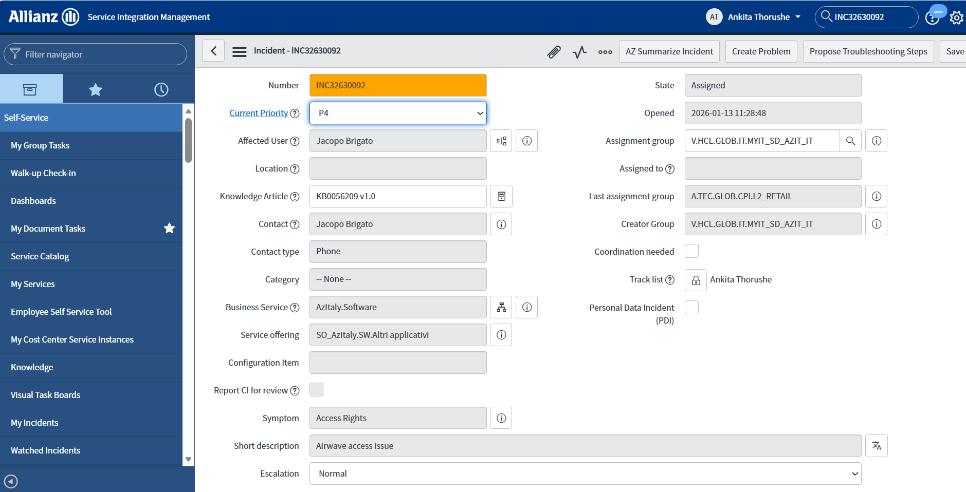

When Incident should be marked in 'Customer Info Required' status in ServiceNow:
Require Clarification: In 2 conditions have mentioned below:
a. When incident has insufficient information for analysis.
b. When more information or clarification is required from user.
Steps to do:
1.Click on 'Customer Info Required' button on top.
2. Enter below details and click customer Info Required.
Follow-Up due date - Set as tentative date when fix will be deployed in production. Follow up emails will not be set until this date to the assignee.
Work notes - mentioning reason for marking the 'customer info required".
Additional comments-supporting the state change
On follow up date and time, a follow up email is automatically sent to 'Assignee' of incident like the one attached here as a reminder.
Incident can be resumed by clicking on 'Resume', for any status change or updates required to the incident
Standard Template:
Put ticket in Cust info required  -> Add your name in track list  -> Click on assign to me  -> Click on Cust info required  --> Added in work notes  waiting for customer to provide details.  -> added below details in additional comment  Dear Affected user,  Could you please provide steps taken?  Claim Number and how many user affected?  Br  Your name.  Add 1st reminder follow up date after 1 day - keep one day gap (1 working day and then  for second reminder keep 2 days gap(don't consider follow up date)  for third reminder keep 2 days gap  --> Again click on cust info required  --> Add Impacted OE in short description like ITMP AUS  --> click on save | Cust info required resuming ticket  -->Click on resume  --> add work note as resuming for further process  --> click on resume  --> click on cust info required  --> add additional comment  Dear (affected user),  This email is regarding your reported incident "FNOL Issues"  Could you please confirm are you still facing this issue? If yes, please provide below information for our further investigation -  - Claim number that you are lodging  - Which steps did you take?  Please provide above information as soon as possible.  Waiting for response!  Best Regards,  Your name.  Claim Ops L2  -->Add work note as reminder email send to user for confirmation  --> change follow up date after 2 working days (if todays date is 16/06 then change it as 18/06)  -->Click on cust info required  ---Click on save

Managing Parent-Child Incident
When there are multiple incidents reported for same underlying cause then all related incidents should the linked in ServiceNow as "Parent Child”
Main incident in marked as Parent incident, and all same/similar incidents are inked as child Incident
The issue is tracked via parent incident only
While marking any incidents as parent chid, we need to follow below steps:
-> Assign all incident on your name(Add name to the Track List->click on assign me)
-> Decide first in that all which incident you want to make parent incident(You can select any incident as a parent incident)
-> Make sure that For parent incident we have to add proper work note, and added the Assignment group->click on save.
You can take reference from -> INC30229570(This incident we added as a parent incident)
->Go to the child incident -> Navigate Related Notes -> Copy Parent Incident no & Paste Parent Incident No. in the Parent Incident Field-> Remove your name from Assigned To Field -> Click on Save
-> next paste the same Assignment group from parent incident-> click on save.
In Below image you can see linked child incidents to Parent incident
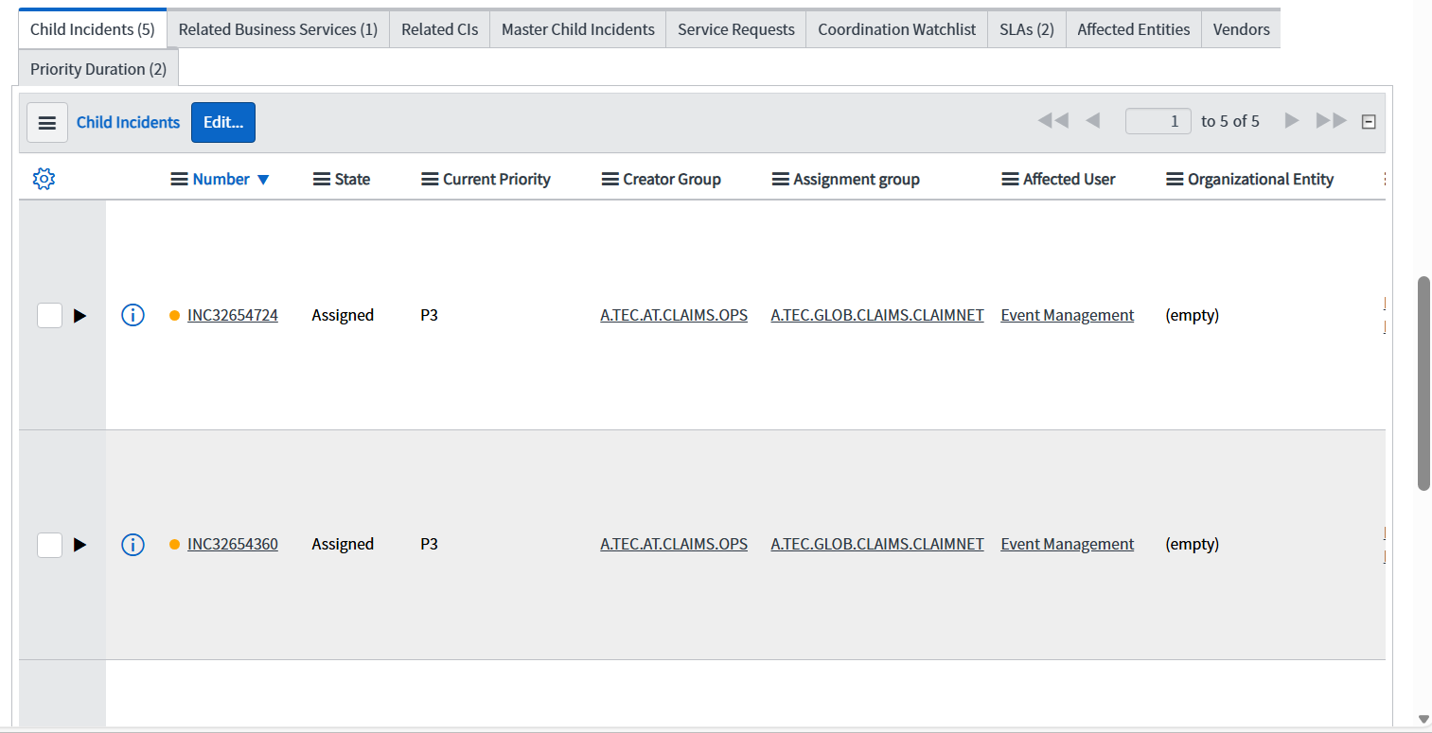
Using Service Now-Points to remember
1) For new Incidents always review:
Category and Subcategory
b. Business service and service offering
c. Affected OE
2) While reassigning incidents.
a. Update Business service and service offering for relevant area
b. Assignment group
c. Notes mentioning your analysis and reason for reassignment
3) When asking for more information from user:
a. Mark the incident in customer info required
b. Update notes clearly on what information is required from user
c. An auto email is sent to affected user from ServiceNow with your comments
d. 3 follow-ups should be sent to user if response isn't received. Each follow up should be sent in gap of 3 days.
e. If no response is received in 3 follow-ups, then Incident should be marked as 'Resolved'.
4) When issue is resolved, assign the incident to L2 with appropriate comments:
a. L2 will mark incident in 'Customer info required'
b. Validate Category/BS/SO/ Affected OE before marking the incident as resolved.
c. Mark resolved either once user confirms that the issue is resolved or doesn't responds in 3 follow-ups
d. Update close code, cause code and close notes.
e. The close notes are visible for the affected user. Intended to help understand why the Incident record was closed and what measures were performed. Do not enter sentences like "Issue resolved". Describe the resolution.
5) User has option to 'Accept' or 'Reject' Solution, once the incident is marked as 'Resolved
a. Incident is automatically marked as 'Closed' in 5 days
b. After 5 days of incidents being 'resolved', incident cannot be reopened.
6) Whenever Incident is resolved with temporary workaround/solution, a IMP ticket should be created to track permanent solution. The JMP ticket could be a defect or a user story depending on root cause of the issue.
7) While updating/resolving parent-child incidents, always remember all incidents are updated/closed when any linked ticket is updated.
8) Please note only "Additional comments" added to ServiceNow are visible to user.
9) Automatic Emails are sent to user when incident status is changed to customer info required or resolved. Hence clear comments should be added while changing status as these are sent to user.
Incidents For Reference:
- INC31632420 – Misrouted Incident
- INC30479672 – Dynatrace Alert
- INC32613120 – Parent Incident
- INC30528125
- INC31137187 – Customer Info Required

